Step Functions with Manual Approval Steps

**Resources and permissions:**

1. Step function with state machine
   * + The step function IAM role requires the permissions like
       - SQSSendMessageScopedAccessPolicy
       - XRayAccessPolicy
       - AmazonSNSFullAccess

2. Lambda Function

* We required three lambda functions they are
  + callback_handler
  + Approvedhandler
  + Rejecthandler
    - The role permission required for callback_handler role
      * AWSLambdaBasicExecutionRole
      * AmazonSQSFullAccess
      * AmazonSESFullAccess
    - The role permissions required for Approvedhandler role
      * AWSLambdaBasicExecutionRole
      * AmazonAPIGatewayInvokeFullAccess
      * AWSStepFunctionsFullAccess
    - The role permissions required for Rejecthandler role
      * AWSLambdaBasicExecutionRole
      * AmazonAPIGatewayInvokeFullAccess
      * AWSStepFunctionsFullAccess

3. Simple Email Service

* A Simple Email Service with mail subscription

4. Simple Queues Service

* A Simple Queues Service is required to Trigger the callback_handler lambda function to generate Email from Simple Email Service

5. API Gateway

* API Gateway is required with two routes to trigger two lambda function to be configured

**Process and configure with resources:**

**Step function Configuration:**

Create a step function with SQS as a starting step which is connected to the choice step and the choice step connected with two SNS as Approved and Reject notifications

**SQS Configuration:**

Create SQS to trigger callback lambda function from step function

**callback_handler:**

This lambda function is Triggered by SQS from step function but the trigger is set from lambda function, in this lambda function we write a body of the mail and name and mail address of an employee as input from step function execution input and trigger a mail through Simple Email Service

**Simple Email Service:**

As the lambda trigger a mail body and address it send a mail with two links which described in lambda function and the mail is send to the input mail successfully

**API Gateway:**

After the user who received the mail click on one of the links in the mail the API Gateway gets the routes with each link separately will trigger the lambda function I.e.: if the user clicks the link of approve the approve route will active and triggers the approve lambda function,

**Approve/Deny Lambda functions:**

After getting the user response from API Gateway, based on the response of the user the API Gateway, one of the lambda will trigger

**Choice in step function:**

In this step will wait for the response after SQS step got executed after getting the response from one of the lambda function it will make a choice based on condition and the condition is like

i.e.: $.body == "Approved" Based on the condition it will direct to Approved or reject

**Semple Notification Service:**

In both choices the SNS topic will trigger and send the Email to the mail ID which subscribed in SNS topic

Note: In the step function only SQS and choice stages are configured and the steps like callback lambda function, Simple Email Service, API Gateway, Approve/Deny lambda functions are out of the Step functions.

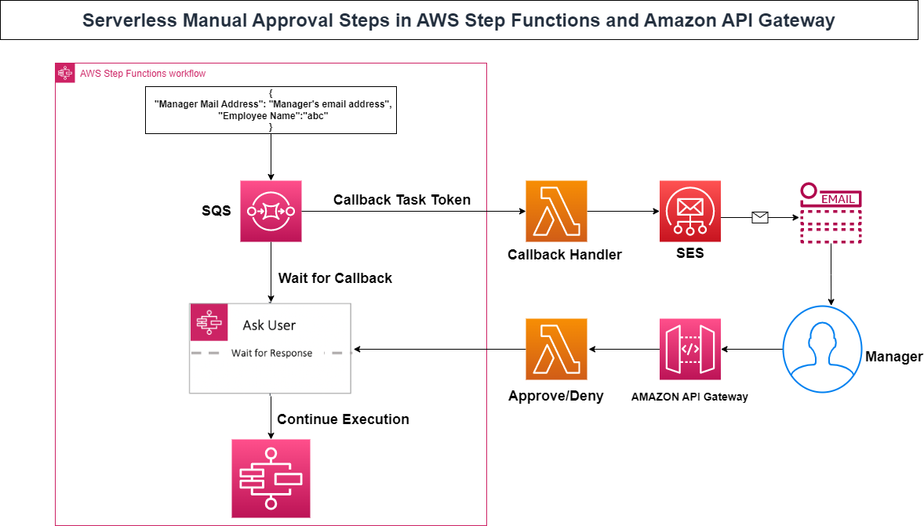

**Result:** While we executing the Step function, we will give the input in json format like

{

"Manager Mail Address":"aluru.bhanuvenkatesh@gmail.com",

"Employee Name":"BhanuVenkatesh"

}

Here these inputs are going to place in call back lambda function as the mail which has to be sent in next step the SQS is triggered from here up to choice which will execute out of the step function, hence the SQS topic will trigger call back lambda function which configure while creating lambda function and the lambda function will make a body and the input variables are defined in that function and it sent the mail through Simple Mail Service

After the user click on one of the link it will trigger to the one of the routes in API Gateway which configured separately these API calls, for each API calls has separate lambda functions called Approve or Deny.

From here the steps will again be executed step functions, up to now the choice step is on hold, after the lambda output gets it will make a choice based on the output and passes to the specific step then the SNS topic will trigger the Mail which is sending mail based on input payload.